**Question!**

1. Explain the difference between git commit and git push?

Answer : `git commit` is used to save changes to your local Git repository, creating snapshots of your work with descriptive commit messages. On the other hand, `git push` is used to upload your local commits to a remote repository, allowing you to share your changes with others and keep your work synchronized between your local machine and the remote repository. Together, these commands are essential for effective version control and collaboration when using Git.

2. In the above steps, we firstly create a repository in Github then clone it to the local

computer to be modified. Is it possible to create the project folder and then push

(upload) it to Github? Proove it!

Answer : You can create a project folder locally and then push it to GitHub by following these steps:

1. Create a project folder onYyour local computer.

2. Initialize a Git repository in the project folder using `git init`.

3. Add your project files to the Git repository using `git add` and commit them with a commit message using `git commit`.

4. Create a new GitHub repository on the GitHub website.

5. Link your local Git repository to the GitHub repository using `git remote add origin`.

6. Push your local repository to GitHub using `git push -u origin master`.

**Question!**

1. What is the use of Pull requests?

Answer : Pull requests let you tell others about changes you've pushed to a branch in a repository on GitHub. Once a pull request is opened, you can discuss and review the potential changes with collaborators and add follow-up commits before your changes are merged into the base branch.

2. Why do we need to create branch?

Answer : When you want to add a new feature or fix a bug no matter how big or how small you spawn a new branch to encapsulate your changes. This makes it harder for unstable code to get merged into the main code base, and it gives you the chance to clean up your future's history before merging it into the main branch.

**Question!**

1. What steps do you take to invite team members to join your board?

Answer : To invite team members to join your board in Trello, you can follow these steps:

1. Open Your Board

2. Access the Board Menu

3. Click "Members"

4. Invite Members

5. Enter Email Addresses or Trello Usernames

6. Send Invitations

7. Accept Invitations

2. Is it possible to make a board not from scratch (adding a list one by one), if so, how

we can do that?

Answer : Yes, it's possible to create a board in Trello without starting from scratch, here's how to do it:

1. Go to Trello Templates https://trello.com/templates

2. Browse and Select a Template

3. Create a Board from the Template

4. Customize the New Board

5. Access the New Board

Using an existing board as a template or selecting a pre-made template can help you quickly set up a new board in Trello.

**Assignment**

1. Make groups/teams, and there are 3 students in each team!

2. Create a repository based on the topic chosen by your group, invite all team members

to the repository.

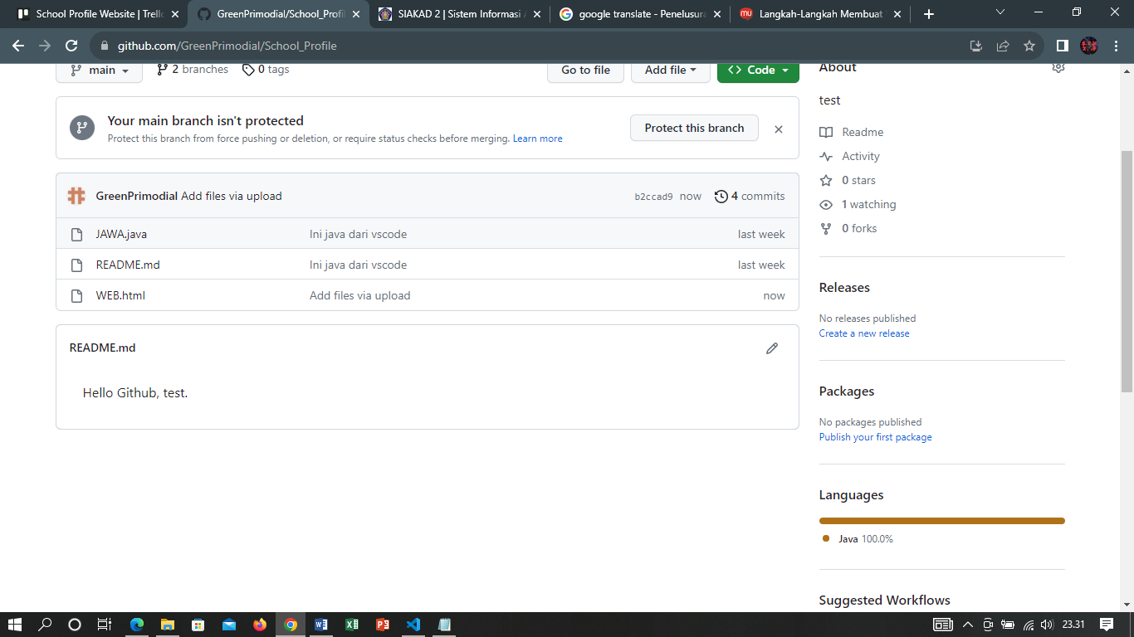

3. Create a Kanban Board with a board title complete with cards according to the project

topic your group has chosen, invite all team members to the board

